**LIDC Meeting 9/14/2016**

For code visit <https://github.com/ysriram1/Lung-Nodule-Identification>

**Work Done:**

* Generated 10 Eigen nodule images for each class of images that belong to the dataset with the 809 images.
* Class labels have been obtained from Matt.
* PCA was performed separately for each category
* Scree Plots have been added to visualize the variation accounted for by the PCs

**Eigen Nodules:**

Scree Plots:  
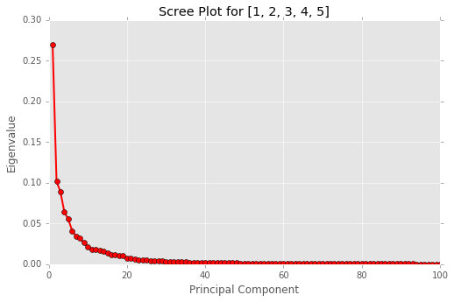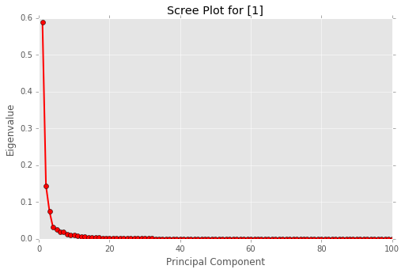

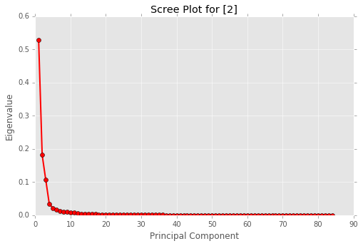 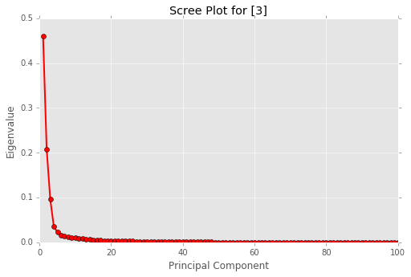

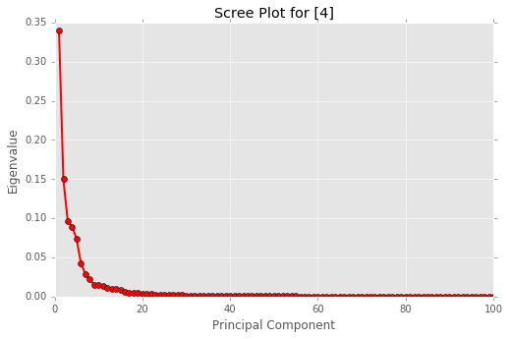 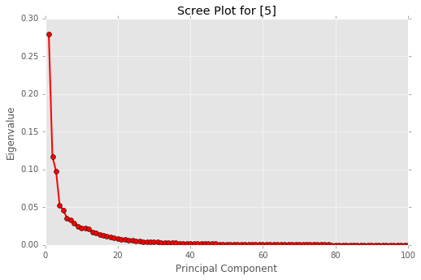

Class Counts:

|  |  |
| --- | --- |
| **Class** | **Count** |
| 3 | 347 |
| 4 | 155 |
| 1 | 117 |
| 5 | 106 |
| 2 | 84 |
| All | 809 |

Eigen Values:

|  |  |  |  |  |  |  |
| --- | --- | --- | --- | --- | --- | --- |
| **Eigen Value** | **All** | **1** | **2** | **3** | **4** | **5** |
| **1** | 0.27 | 0.59 | 0.53 | 0.46 | 0.34 | 0.28 |
| **2** | 0.10 | 0.14 | 0.18 | 0.21 | 0.15 | 0.12 |
| **3** | 0.09 | 0.07 | 0.11 | 0.10 | 0.10 | 0.10 |
| **4** | 0.06 | 0.03 | 0.03 | 0.04 | 0.09 | 0.05 |
| **5** | 0.06 | 0.03 | 0.02 | 0.02 | 0.07 | 0.05 |
| **6** | 0.04 | 0.02 | 0.02 | 0.02 | 0.04 | 0.04 |
| **7** | 0.03 | 0.02 | 0.01 | 0.01 | 0.03 | 0.03 |
| **8** | 0.03 | 0.01 | 0.01 | 0.01 | 0.02 | 0.03 |
| **9** | 0.03 | 0.01 | 0.01 | 0.01 | 0.02 | 0.02 |
| **10** | 0.02 | 0.01 | 0.01 | 0.01 | 0.01 | 0.02 |
| **Sum** | **0.73** | **0.94** | **0.93** | **0.89** | **0.87** | **0.74** |

|  |  |  |  |
| --- | --- | --- | --- |
| **Eigen Nodule** | **All** | **1** | **2** |
| **1** | C:\Users\SYARLAG1\Documents\Lung-Nodule-Identification\eigenNodules\1,2,3,4,5_PC1.png | C:\Users\SYARLAG1\Documents\Lung-Nodule-Identification\eigenNodules\1_PC1.png | C:\Users\SYARLAG1\Documents\Lung-Nodule-Identification\eigenNodules\2_PC1.png |
| **2** | C:\Users\SYARLAG1\Documents\Lung-Nodule-Identification\eigenNodules\1,2,3,4,5_PC2.png | C:\Users\SYARLAG1\Documents\Lung-Nodule-Identification\eigenNodules\1_PC2.png | C:\Users\SYARLAG1\Documents\Lung-Nodule-Identification\eigenNodules\2_PC2.png |
| **3** | C:\Users\SYARLAG1\Documents\Lung-Nodule-Identification\eigenNodules\1,2,3,4,5_PC3.png | C:\Users\SYARLAG1\Documents\Lung-Nodule-Identification\eigenNodules\1_PC3.png | C:\Users\SYARLAG1\Documents\Lung-Nodule-Identification\eigenNodules\2_PC3.png |
| **4** | C:\Users\SYARLAG1\Documents\Lung-Nodule-Identification\eigenNodules\1,2,3,4,5_PC4.png | C:\Users\SYARLAG1\Documents\Lung-Nodule-Identification\eigenNodules\1_PC4.png | C:\Users\SYARLAG1\Documents\Lung-Nodule-Identification\eigenNodules\2_PC4.png |
| **5** | C:\Users\SYARLAG1\Documents\Lung-Nodule-Identification\eigenNodules\1,2,3,4,5_PC5.png | C:\Users\SYARLAG1\Documents\Lung-Nodule-Identification\eigenNodules\1_PC5.png | C:\Users\SYARLAG1\Documents\Lung-Nodule-Identification\eigenNodules\2_PC5.png |
| **6** | C:\Users\SYARLAG1\Documents\Lung-Nodule-Identification\eigenNodules\1,2,3,4,5_PC6.png | C:\Users\SYARLAG1\Documents\Lung-Nodule-Identification\eigenNodules\1_PC6.png | C:\Users\SYARLAG1\Documents\Lung-Nodule-Identification\eigenNodules\2_PC6.png |
| **7** | C:\Users\SYARLAG1\Documents\Lung-Nodule-Identification\eigenNodules\1,2,3,4,5_PC7.png | C:\Users\SYARLAG1\Documents\Lung-Nodule-Identification\eigenNodules\1_PC7.png | C:\Users\SYARLAG1\Documents\Lung-Nodule-Identification\eigenNodules\2_PC7.png |
| **8** | C:\Users\SYARLAG1\Documents\Lung-Nodule-Identification\eigenNodules\1,2,3,4,5_PC8.png | C:\Users\SYARLAG1\Documents\Lung-Nodule-Identification\eigenNodules\1_PC8.png | C:\Users\SYARLAG1\Documents\Lung-Nodule-Identification\eigenNodules\2_PC8.png |
| **9** | C:\Users\SYARLAG1\Documents\Lung-Nodule-Identification\eigenNodules\1,2,3,4,5_PC9.png | C:\Users\SYARLAG1\Documents\Lung-Nodule-Identification\eigenNodules\1_PC9.png | C:\Users\SYARLAG1\Documents\Lung-Nodule-Identification\eigenNodules\2_PC9.png |
| **10** | C:\Users\SYARLAG1\Documents\Lung-Nodule-Identification\eigenNodules\1,2,3,4,5_PC10.png | C:\Users\SYARLAG1\Documents\Lung-Nodule-Identification\eigenNodules\1_PC10.png | C:\Users\SYARLAG1\Documents\Lung-Nodule-Identification\eigenNodules\2_PC10.png |

|  |  |  |  |
| --- | --- | --- | --- |
| **Eigen Nodule** | **3** | **4** | **5** |
| **1** | C:\Users\SYARLAG1\Documents\Lung-Nodule-Identification\eigenNodules\3_PC1.png | C:\Users\SYARLAG1\Documents\Lung-Nodule-Identification\eigenNodules\4_PC1.png | C:\Users\SYARLAG1\Documents\Lung-Nodule-Identification\eigenNodules\5_PC1.png |
| **2** | C:\Users\SYARLAG1\Documents\Lung-Nodule-Identification\eigenNodules\3_PC2.png | C:\Users\SYARLAG1\Documents\Lung-Nodule-Identification\eigenNodules\4_PC2.png | C:\Users\SYARLAG1\Documents\Lung-Nodule-Identification\eigenNodules\5_PC2.png |
| **3** | C:\Users\SYARLAG1\Documents\Lung-Nodule-Identification\eigenNodules\3_PC3.png | C:\Users\SYARLAG1\Documents\Lung-Nodule-Identification\eigenNodules\4_PC3.png | C:\Users\SYARLAG1\Documents\Lung-Nodule-Identification\eigenNodules\5_PC3.png |
| **4** | C:\Users\SYARLAG1\Documents\Lung-Nodule-Identification\eigenNodules\3_PC4.png | C:\Users\SYARLAG1\Documents\Lung-Nodule-Identification\eigenNodules\4_PC4.png | C:\Users\SYARLAG1\Documents\Lung-Nodule-Identification\eigenNodules\5_PC4.png |
| **5** | C:\Users\SYARLAG1\Documents\Lung-Nodule-Identification\eigenNodules\3_PC5.png | C:\Users\SYARLAG1\Documents\Lung-Nodule-Identification\eigenNodules\4_PC5.png | C:\Users\SYARLAG1\Documents\Lung-Nodule-Identification\eigenNodules\5_PC5.png |
| **6** | C:\Users\SYARLAG1\Documents\Lung-Nodule-Identification\eigenNodules\3_PC6.png | C:\Users\SYARLAG1\Documents\Lung-Nodule-Identification\eigenNodules\4_PC6.png | C:\Users\SYARLAG1\Documents\Lung-Nodule-Identification\eigenNodules\5_PC6.png |
| **7** | C:\Users\SYARLAG1\Documents\Lung-Nodule-Identification\eigenNodules\3_PC7.png | C:\Users\SYARLAG1\Documents\Lung-Nodule-Identification\eigenNodules\4_PC7.png | C:\Users\SYARLAG1\Documents\Lung-Nodule-Identification\eigenNodules\5_PC7.png |
| **8** | C:\Users\SYARLAG1\Documents\Lung-Nodule-Identification\eigenNodules\3_PC8.png | C:\Users\SYARLAG1\Documents\Lung-Nodule-Identification\eigenNodules\4_PC8.png | C:\Users\SYARLAG1\Documents\Lung-Nodule-Identification\eigenNodules\5_PC8.png |
| **9** | C:\Users\SYARLAG1\Documents\Lung-Nodule-Identification\eigenNodules\3_PC9.png | C:\Users\SYARLAG1\Documents\Lung-Nodule-Identification\eigenNodules\4_PC9.png | C:\Users\SYARLAG1\Documents\Lung-Nodule-Identification\eigenNodules\5_PC9.png |
| **10** | C:\Users\SYARLAG1\Documents\Lung-Nodule-Identification\eigenNodules\3_PC10.png | C:\Users\SYARLAG1\Documents\Lung-Nodule-Identification\eigenNodules\4_PC10.png | C:\Users\SYARLAG1\Documents\Lung-Nodule-Identification\eigenNodules\5_PC10.png |

|  |  |  |  |
| --- | --- | --- | --- |
| **Class** | **Eigen Nodule for PC1 – Normalized and then Global Scaled** | **Eigen Nodule for PC1 – Global Scaled** | **Eigen Nodule for PC1 – Local Bounds** |
| **All** | **C:\Users\SYARLAG1\Documents\Lung-Nodule-Identification\normalizedEigenNodulesGlobalScaled\1,2,3,4,5_PC1.png** | **C:\Users\SYARLAG1\Documents\Lung-Nodule-Identification\eigenNodulesGlobalScaled\1,2,3,4,5_PC1.png** | C:\Users\SYARLAG1\Documents\Lung-Nodule-Identification\eigenNodulesLocalScaled\1,2,3,4,5_PC1.png |
| **1** | **C:\Users\SYARLAG1\Documents\Lung-Nodule-Identification\normalizedEigenNodulesGlobalScaled\1_PC1.png** | **C:\Users\SYARLAG1\Documents\Lung-Nodule-Identification\eigenNodulesGlobalScaled\1_PC1.png** | C:\Users\SYARLAG1\Documents\Lung-Nodule-Identification\eigenNodulesLocalScaled\1_PC1.png |
| **2** | C:\Users\SYARLAG1\Documents\Lung-Nodule-Identification\normalizedEigenNodulesGlobalScaled\2_PC1.png | C:\Users\SYARLAG1\Documents\Lung-Nodule-Identification\eigenNodulesGlobalScaled\2_PC1.png | C:\Users\SYARLAG1\Documents\Lung-Nodule-Identification\eigenNodulesLocalScaled\2_PC1.png |
| **3** | C:\Users\SYARLAG1\Documents\Lung-Nodule-Identification\normalizedEigenNodulesGlobalScaled\3_PC1.png | C:\Users\SYARLAG1\Documents\Lung-Nodule-Identification\eigenNodulesGlobalScaled\3_PC1.png | C:\Users\SYARLAG1\Documents\Lung-Nodule-Identification\eigenNodulesLocalScaled\3_PC1.png |
| **4** | C:\Users\SYARLAG1\Documents\Lung-Nodule-Identification\normalizedEigenNodulesGlobalScaled\4_PC1.png | C:\Users\SYARLAG1\Documents\Lung-Nodule-Identification\eigenNodulesGlobalScaled\4_PC1.png | C:\Users\SYARLAG1\Documents\Lung-Nodule-Identification\eigenNodulesLocalScaled\4_PC1.png |
| **5** | C:\Users\SYARLAG1\Documents\Lung-Nodule-Identification\normalizedEigenNodulesGlobalScaled\5_PC1.png | C:\Users\SYARLAG1\Documents\Lung-Nodule-Identification\eigenNodulesGlobalScaled\5_PC1.png | C:\Users\SYARLAG1\Documents\Lung-Nodule-Identification\eigenNodulesLocalScaled\5_PC1.png |

|  |  |  |
| --- | --- | --- |
|  | .TIFF image generated with negative values | Original (Scaled with Local Bounds) |
| PC1 for ALL classes | C:\Users\SYARLAG1\Documents\Lung-Nodule-Identification\negativeImagesTIFF\1,2,3,4,5_PC1.TIFF | C:\Users\SYARLAG1\Documents\Lung-Nodule-Identification\eigenNodulesLocalScaled\1,2,3,4,5_PC1.png |

**LIDC Meeting 9/22/2016**

1. Performed Global Scaling of the Eigen vectors instead of local scaling and clipped the 0 of the original image to 127 of the scaled image.
2. Performed Local Scaling after clipping to the 0 of the original image to 127 of the scaled image.
3. Generated .TIFF images as is without any scaling

All images and code is at <https://github.com/ysriram1/Lung-Nodule-Identification>